Eric Burnley, PGA
Director of Instruction – Kimberton Golf Club
Lesson Pricing & Packages

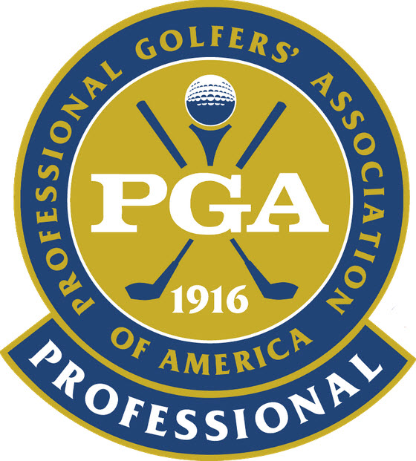
One – Hour Lesson

Individual $65
3 Pack/ Individual $160`
Pair /2 people $80
Group/ 3 or more $100
Junior (18 & Under) $50

1/2 Hour Lesson
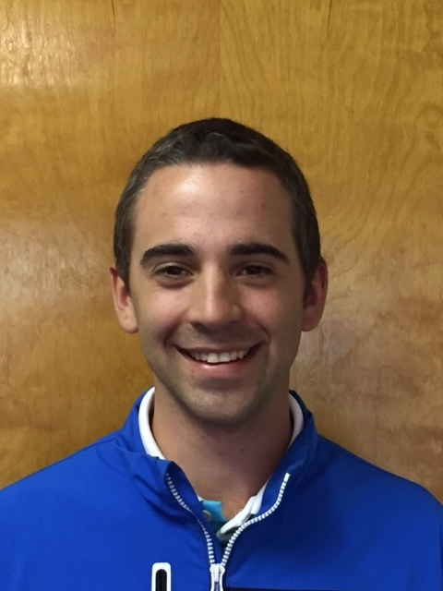

Individual $35
3 Pack Individual $80
Pair/ 2 People $40
Group/ 3 or more $50
Junior (18 & Under) $30

- All lessons are tailored to each individual student
- For large clinic and group events please contact Eric for scheduling & Pricing
Playing Lessons
3 Holes $65
9 Holes $150

